# PROJECT 2

## **Usability Testing**

The web designed for educational purposes. The target is the parents with children, and 4-year-old children and older.

The purpose of usability testing is to identify usability problems with the design as early as possible, so they can be fixed before the design is implemented. There are many factors that I’m testing including:

* Intuitive design: understanding of the whole picture of the software and how to use it.
* Learnability: How easy is it for new users to perform a task. Whether there is help or a hint?
* Efficiency: For experienced users, how much times do they take to complete tasks?
* Memorability: When users return to the website after a period of not using it, how easily can they re-establish proficiency?
* Error frequency and severity: how many errors do the users make, how serious the errors are, how easily can they recover from the errors?
* Satisfaction: Does user like the website?

As the structure of the test, I’m using Beta testing. I gave the near-complete website that my group made to individuals who are happy to try our website and provide critical feedback. This testing method allows me to ask users questions after they have tried the website and have them file bug reports.

For the pilot test. I have some question that has been testing with some friends that working in the IT industry. They gave positive feedback about the questions that make up the usability test that I used.

I have asked 6 of my classmates to participate in my test. They are Sean, Zac, Jay, Ricardo, Shane, and John. The feedback is positive and constructive. Most of them said that the web runs quite well, easy to use and the design includes all the basic requirements. Some feedback gives space for improvement.

Conclusion.

From this testing, I can conclude that they enjoyed the app, but there are some feedbacks for improvement that they gave me. For Ricardo, he suggests that we can fix the images that are stretched. Shane suggest that we can add some sound to the homepage. The rest of the people demand for playable games. And we need to fix some minor issues like resize for mobile version, some button and link that are not working for some computers.

**Feedback from 6 participants:**

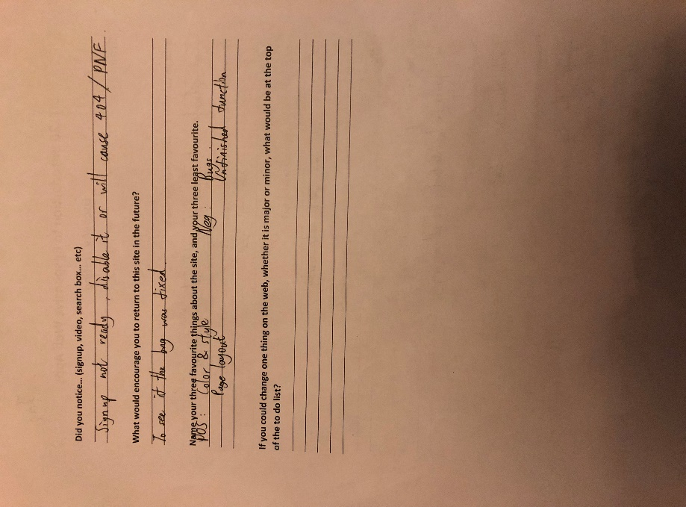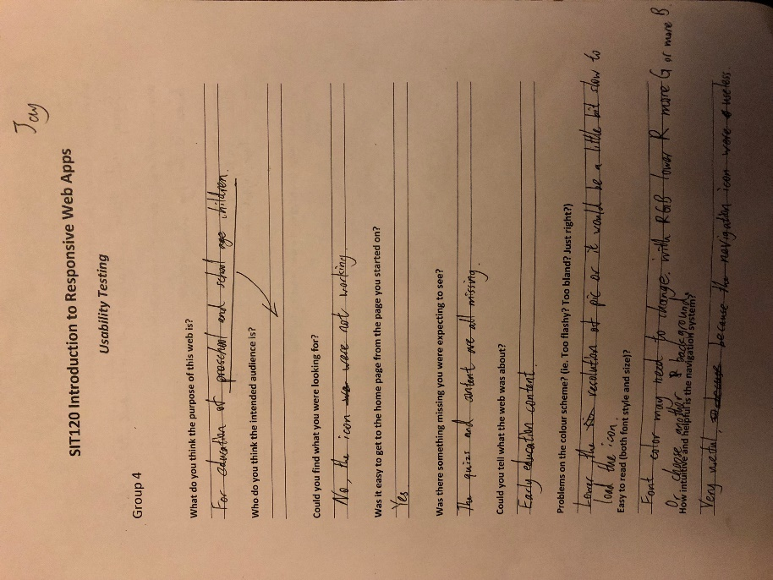1/ Jay

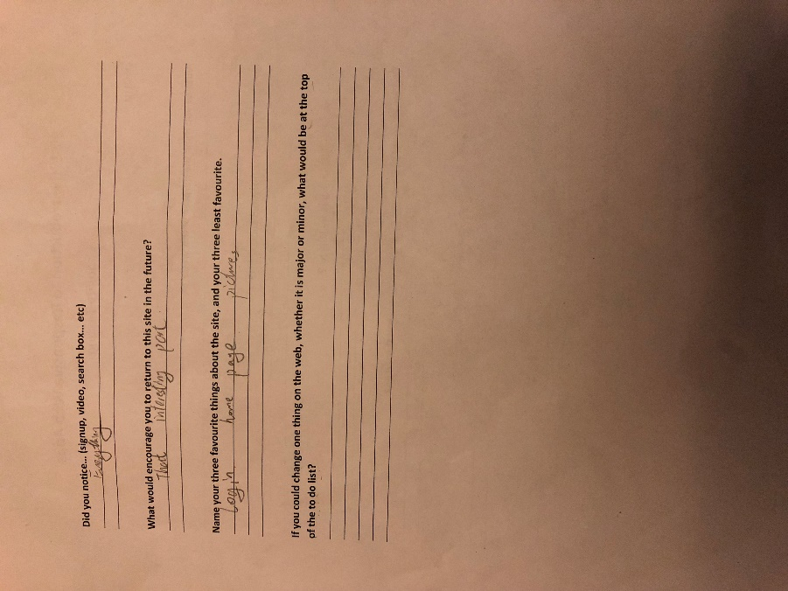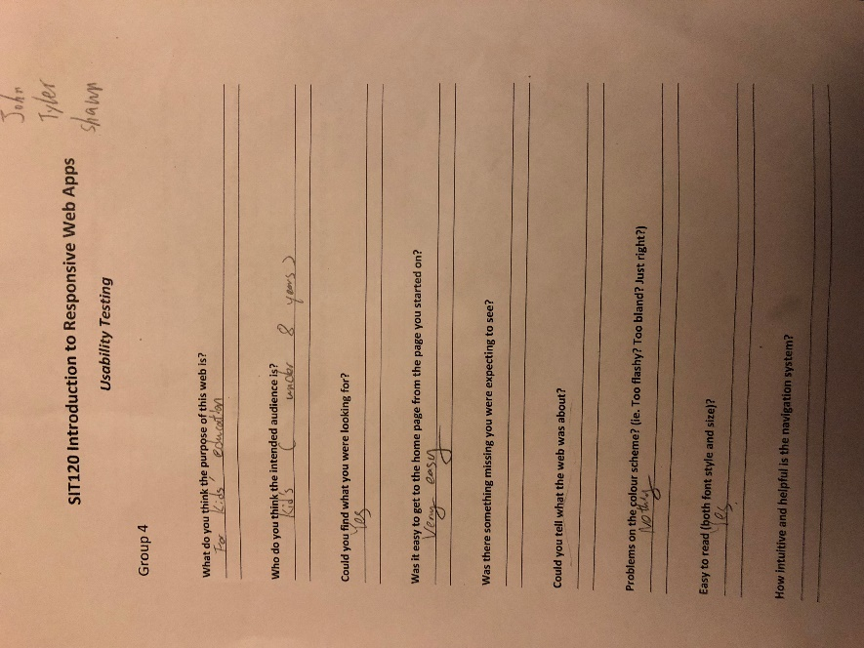2/ John +Tyler +Shawn

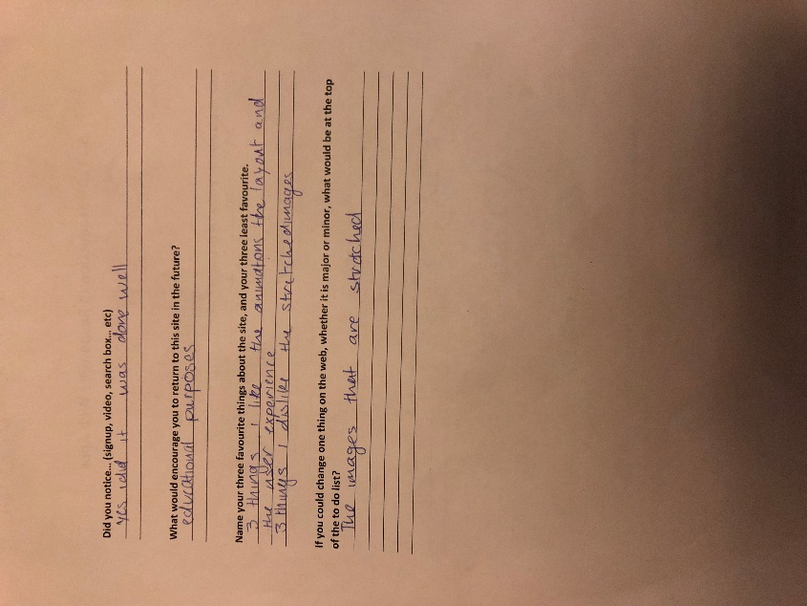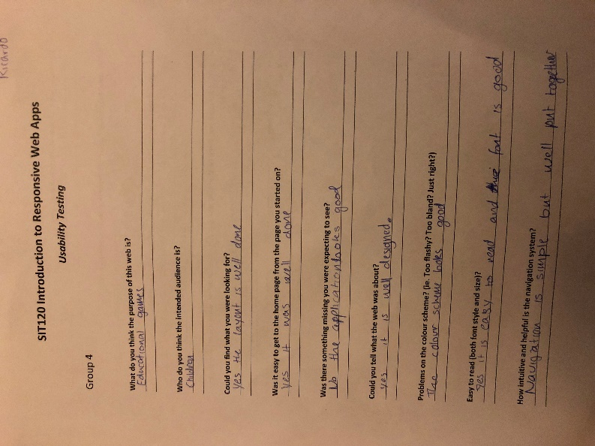3/ Ricardo

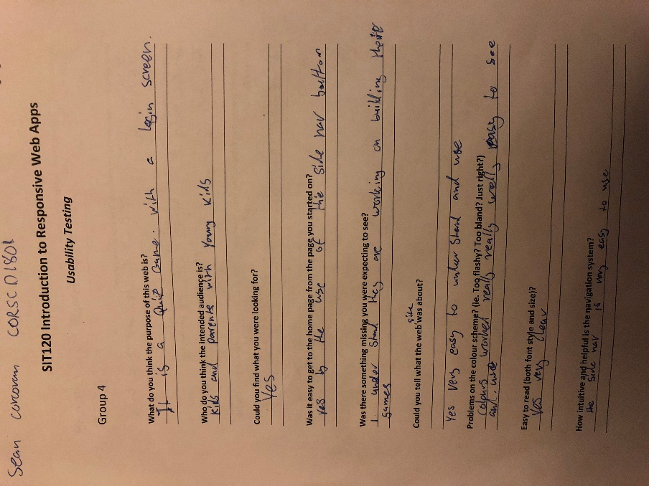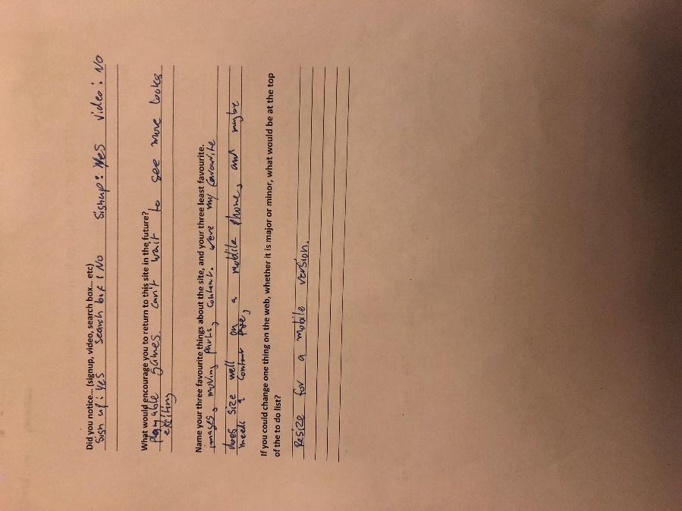4/ Sean

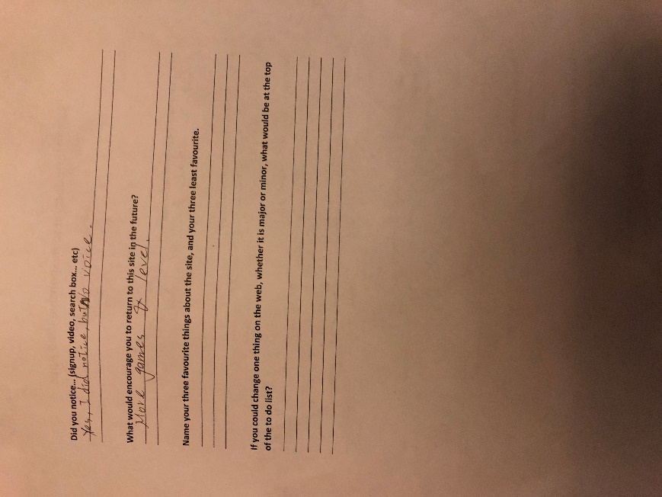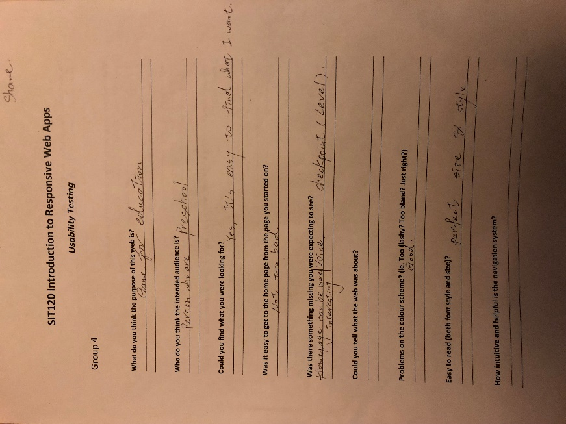5/ Shane

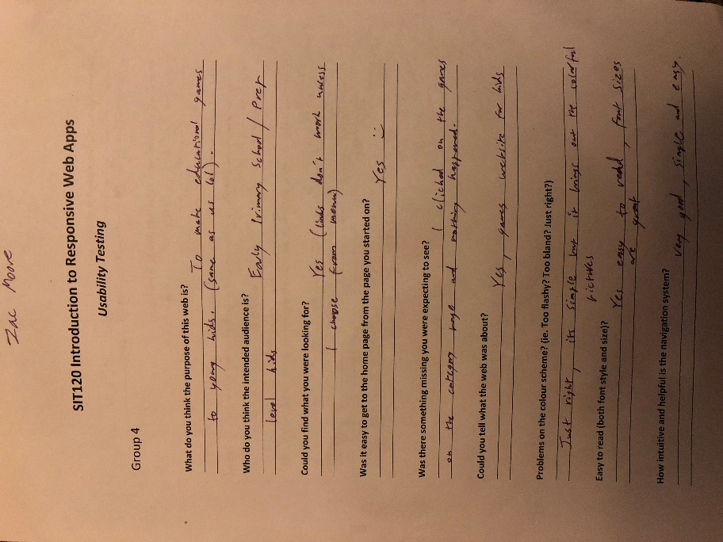6/ Zac

